To: | Cabinet
Date: | 17 September 2025
Report of: | Clive Tritton, Director of Economy, Regeneration and Sustainability
Title of Report: | Appropriation of land at Underhill Circus to a planning purpose

Summary and recommendations
Decision being taken: | This report recommends the appropriation of land (change the statutory basis on which it is held by the Council) within the General Fund (“GF”) to the Housing Revenue Account (“HRA”) and the appropriation of the land for planning purposes. The land is currently held as garages and for public open space purposes at Underhill Circus (the “Land”) for the objective of building affordable housing.
Key decision: | No, https://mycouncil.oxford.gov.uk/mgIssueHistoryHome.aspx?IId=40401&PlanId=537&RPID=43624792
Cabinet Member: | Councillor Ed Turner, Cabinet Member for Finance and Asset Management  Councillor Linda Smith, Cabinet Member for Housing
Corporate Priority: | More Affordable Housing
Policy Framework: | Housing and Homelessness Strategy 2023 to 2028

Recommendation(s): That Cabinet resolves to:
- Note that following the statutory public notification process of the Council’s intention to appropriate the Land to planning purposes, no written representations were received in response to the public notice; and
2. | Recommend the appropriation of the land in the Council’s ownership at Underhill Circus (see Image 1) (“the Land”), to planning purposes to facilitate its future development for new affordable housing; and
3. | Recommend to Council the appropriation of the land owned by Oxford City Council that forms the development site for housing at Underhill Circus from the General Fund (“GF”) into the Housing Revenue Account (“HRA”) at the established red book valuation figure. A further report to Council is to be timetabled between the granting of planning consent summer 2026 for the new development and the completion of the new homes end 2027, to ensure the appropriation aligns with the delivery phase of the project.

Appendices
Appendix No. | Appendix Title | Exempt from Publication
Appendices 1a and 1b | Notice of Appropriation and site location plan | No
Appendix 2 | Equality Impact Assessment | No
Appendix 3 | Appropriation valuation | Yes, This information is exempted from publication under Schedule 12A to the Local Government Act 1972 on the following basis:  Commercial Sensitivity

Introduction and background
- The Council continues to develop a supply programme to deliver more affordable housing through multiple work streams, including the delivery of homes through the Council’s housing company – OCHL; direct delivery by the Council; joint ventures; regeneration schemes; acquisitions; and enabling activity with Registered Providers, community-led housing groups, and other partners. The Council seeks to deliver over 1,600 affordable tenure homes across the next four years (to March 2029), with at least 850 of those at the most affordable Social Rent level.
- OCHL continue to deliver an extensive programme of development schemes in accordance with the OCHL business plan.

Scheme information
- This report concerns a single development within the Affordable Housing Supply Programme: Land at Underhill Circus, located in the Barton and Sandhills ward.
- The site comprises vacant garages, some of which have been unused for several years. Lessees are not necessarily local residents and, while some garages were historically used in relation to the shops, the garage leases are no longer within the demise of new shop leases. The site has been subject to reports of anti-social behaviour.
- The open space is infrequently used and comprises a small area to the rear of the garages, surrounded by the road.
- The scheme remains subject to planning consent. A multi-disciplinary design team has been appointed to conduct the necessary design development work. The planning application is being prepared for submission in early 2026. This report is separate from the formal planning process, and the information provided is for context and reference only.
- The current proposal is for a 100% affordable housing development, comprising of up to nine homes - Social Rent and Affordable Rent unit (capped at LHA). The final tenure mix between Social Rent and Affordable Rent will be subject to viability considerations.
- The image below details the extent of land to be appropriated at Underhill Circus. The area for appropriation is comprised of the red line plan.

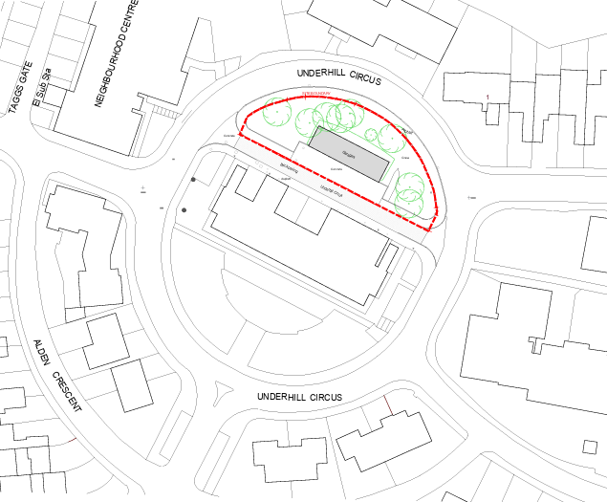
Image 1: Red line drawing of the land at Underhill Circus to be appropriated to a planning purpose.

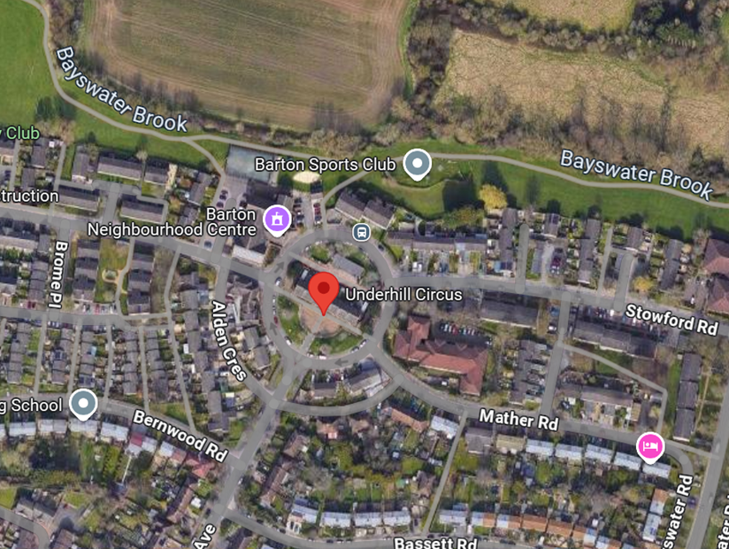
Image 2: Aerial view of the land at Underhill Circus to be appropriated to a planning purpose.
- For more information on the scheme’s background please refer to the Council’s January 2024 Cabinet report on Project approvals, budget and delegations to develop five small sites for affordable housing, using spend from the Brownfield Land Release Fund. A confidential appendix regarding Development scheme appraisal summary information on proposed Underhill and Leiden HRA schemes is referenced in the January 2024 Cabinet Report.

Alternative Options Considered
- The site is currently comprised of vacant garages and an area of open space. Retaining the land in its existing state was considered; however, this option does not contribute to meeting the Council’s strategic housing objectives or make effective use of underutilised brownfield land.
- Disposal to a private developer is a consideration. While this could potentially generate a capital receipt, it would limit the Council’s ability to ensure delivery of genuinely affordable housing and control over design quality and sustainability standards.
- The potential for community-led or non-residential uses on the site was explored; however, no viable proposals have been identified to date. It is worth noting that alternative garage sites are currently being progressed in partnership with the Oxfordshire Community Land Trust (OCLT) as a pilot project.
- The option of delivering a more extensive redevelopment encompassing the entire Underhill Circus area, including the shops, was explored and consulted on. However, due to financial viability issues and the lack of community support, this proposal was not progressed further.

Appropriation of the land from its present use as a garage site for housing
- Appropriation allows a council to change the purpose for which it holds the land. Generally, councils must only use land for the statutory purposes for which it was acquired or following acquisition, appropriated. Appropriation is the process by which land held by a council pursuant to one statutory function is transferred to another statutory function.
- A council may appropriate land held from one purpose to another only if the land in question is no longer required to be held for the purpose for which it is held before the appropriation.
- Where the land to be appropriated is used as open space the council must advertise its intention to appropriate the land and consider any objections made to the proposed appropriation.
- The land at Underhill Circus comprises seven garages with open space adjacent to the rear. Appropriation of the land under the mechanism described above will have the effect of discharging any relevant public trust allowing the council to use the land for other purposes, in this case for housing development.
- In January 2024, Cabinet approved the commencement of the appropriation process for the land at Underhill Circus for planning purposes, as outlined in the report. It was noted at the time that a further report would be brought to Cabinet at a later date to seek approval for the appropriation.
- Following Cabinet’s decision, a notice announcing the Council’s intention to appropriate the land for a ‘Planning Purpose’ at Underhill Circus was published in the Oxford Times for two consecutive weeks from 10 July 2025 to 24 July 2025 (see Appendix 1). A plan showing the location of the area proposed to be appropriated was available for inspection during work hours at the Oxford City Council offices (the Town Hall) during this time.
- Subsequently, to facilitate the proposed housing development, the land must be transferred from the General Fund (“GF”) to the Housing Revenue Account (“HRA”) prior to completion. This report seeks Cabinet’s recommendation to Council for the appropriation of the land at Underhill Circus from the GF to the HRA following planning consent, but prior to the completion of the new homes.

Summary of objections
- In determining whether to appropriate land that is held for public open space purposes the Council has a duty to properly consider any representations received following publication of the public notice and the outcome of the Equality Impact Assessment.
- In further determining whether to appropriate land for planning purposes so as to override rights affecting its development, good practice suggests that Councils should weigh in the balance the reasons of securing the development of the land against the impact the loss of private rights may have on those affected recognising that compensation is payable where such right can be demonstrated to exist.
- No objections or representations were received.

Financial implications
- There were costs associated with publishing the notice of intention to appropriate to a planning purpose.
- The land will be appropriated from the GF to the HRA at a value equal to that of a Red Book valuation. For reference a Royal Institution of Chartered Surveyors (RICS) valuation can be found in confidential Appendix 3.
- The report to Council is to be timetabled between the granting of planning consent summer 2026 for the new development and the completion of the new homes end 2027, to ensure the appropriation aligns with the delivery phase of the project. An up-to-date Red Book valuation will be undertaken to support this.
- The appropriation will result in an increase to the HRA Capital Financing Requirements (CFR) of the valuation figure and a corresponding decrease in the General Fund CFR.

Equalities impact
- Given the nature of the exercise of the powers proposed by the Council it is necessary for the Council to have regard to its public sector equality duty in reaching a final decision to appropriate the Land to planning purposes. The public sector equality duty is an obligation on the council to have due regard in the exercise of its functions to the need to promote equality through the achievement of various equality objectives.
- An Equalities Impact Assessment has been carried out and is included at Appendix 2.
- The Council commits to monitoring the impact of the development through ongoing communication and engagement with the local community.
- The report also details the high housing need within Oxford and the positive impact for families and single people waiting for affordable housing on the housing register.
- Any adverse impacts to the community in undertaking this activity have been considered with mitigating actions undertaken or planned wherever possible. It is considered that these are balanced against improving provision for persons in housing need, through the delivery of more affordable and accessible housing to better meet client needs.

Legal issues
- The land at the Underhill Circus site is intended for residential development and the provision of new affordable housing on the land will contribute to the achievement of the objectives of the Council’s Housing, Homelessness and Rough Sleeping Strategy. Under the circumstances and given the urgent need for housing in the city it is the view of officers that on balance the interest of the community are best served in this case by the appropriation of the land for housing.
- The activities, as set out in this report, relate to the development of homes as affordable housing. This is within the Council’s statutory powers. The general power of competence under the Localism Act 2011 and the Local Authorities (Land) Act 1963 enable the Council to develop land it already owns.
- Under section 122(1) of the Local Government Act 1972 (“LGA 1972”) a local authority “may appropriate for any purpose for which the council are authorised by this or any other enactment to acquire land by agreement any land which belongs to the council and is no longer required for the purpose for which it is held immediately before the appropriation”. This general power of appropriation is subject to section 19(1) of the Housing Act 1985 (“HA 1985”).
- Appropriation from General Fund to the Housing Revenue Account is specifically dealt with in section 19(1) HA 1985. Section 19(1) HA 1985 states that a local housing authority may appropriate for the purposes of Part II of the Housing Act 1985 any land for the time being vested in them or at their disposal and the authority have the same powers in relation to the land so appropriated as they have in relation to land acquired for the purposes of Part II.
- The powers of appropriation under section 122 LGA 1972 are in conjunction with the powers of section 203 of Housing and Planning Act 2016. Section 203 of the Housing and Planning Act 2016 grants a local authority or successor in title the power to appropriate for planning purposes. The effect of section 203 will be that such rights still exist but are overridden and converted to a right of payment.
- Under Parts 4.5 (8) of the Constitution Cabinet is responsible for the decisions set out in the recommendation.

Level of risk
- Key risks identified include the potential for legal challenge to the appropriation process, which has been mitigated through strict adherence to statutory procedures and ongoing legal oversight.
- Delays in securing planning consent and the risk of cost escalation due to unforeseen site constraints are both considered medium likelihood and high impact; these are being addressed through proactive coordination with planning teams and early feasibility work.
- Risks related to inaccurate land ownership data have been minimised through detailed title investigations.
- Political or reputational risks associated with the appropriation of open space are being managed through clear articulation of the public interest case and transparent decision-making.
Carbon and Environmental Considerations
- There are no carbon or environmental considerations in relation to the appropriation to a planning purpose or from the GF to the HRA.

Report author | Dave Scholes
Job title | Affordable Housing Supply Corporate Lead
Service area or department | Economy, Regeneration and Sustainability
Telephone | 01865 529123
e-mail | Dscholes@oxford.gov.uk

